Names:
Syed Sualeh Abbas Rizvi
Burair Haidar Inayatullah

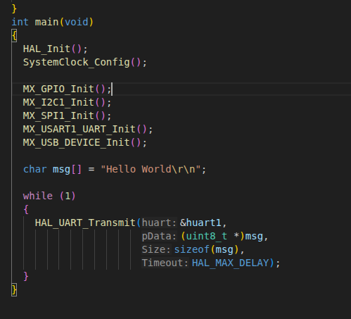
Code change Snippet:

Results:
(was shown to the RA)

Questions:
Question (a)
Answer: “Hello World” example, HAL_UART_Transmit() is usually placed inside the while(1) loop so the message is sent repeatedly, which makes it easy to confirm that the program is running continuously. If the function were placed outside the while(1) loop, the message would be transmitted only once during startup, and then the program would enter the infinite loop doing nothing, which can make it appear as if the UART is not working, especially if you connect the terminal after reset or miss the brief transmission.

Question(b)
Answer: If the baud rate specified in the screen command does not match the baud rate configured in STM32CubeMX, the UART communication will fail, and the terminal will display garbled characters, random symbols, or question marks instead of the intended message. This happens because the terminal and the MCU are interpreting the timing of the bits differently each byte is read incorrectly, leading to corrupted output. In our case, we did that mistake first and it was printing garbage such as “?”.

